Lab #7 – Recursion
Total Points: 50

Introduction
In this lab you will be developing recursive definitions for several problems and then implementing those recursive definitions as Java programs.
Getting Started
Create your GitHub repository and import the code into Eclipse as described on the "How to…" webpage, available from the course homepage. Expand the recursion package.
The Assignment
Develop and implement and test a recursive solution to each of the problems described below. The recursion package contains a stub for each of the problems. You will complete the appropriate method(s) within the stub for each problem.
- Pyramid Area
For this problem you will write a method that computes the number of boxes in a pyramid of boxes based on the number of boxes in the base. The boxes in each layer of the pyramid are stacked directly on top of one another (i.e. not offset between two boxes below). For example, below are shown two pyramids, one with base 5 and one with base 6.
[] [][]
[][][] [][][][]
[][][][][] [][][][][][]
Implement and test the computePyramidBoxes() method in the PyramidBoxCount class. When testing the computePyramidBoxes() method you should be sure to have at least one test method for each base case and at least one test method for each recursive case in your program.
- Exponentiation
In the homework you were asked to give a recursive definition for computing $x^{n}$ (where both $x$ and $n$ are non-negative integer values). The most straight forward recursive definition for $x^{n}$ is:
$x^{n}=1$, if $n=0$
$x^{n}=x×x^{n-1}$, if $n>0$
However, the value of $x^{n}$ can be computed far more efficiently using the fact that if $n$ is even then:
$$x^{n}=x^{n/2}×x^{n/2}$$
Implement and test the exp method in the Exponentiation class, using the more efficient approach just described above. (When $n$ is odd, you will need to use a slight variant of the approach.) When testing the exp method you should be sure to have at least one test method for each base case and at least one test method for each recursive case in your program.
- Efficient Palindrome checker
In class we studied a recursive approach to determining whether a string is a palindrome. This code was in the Recurse2.java file, and it is provided to you again in the Palindrome.java file for this lab. The provided implementation is somewhat inefficient because it relies on calling the substring() method of the String class, and every call to substring() results in the creation of a new String object. In this lab, you must rewrite the Palindrome.java file so that no new String objects are created. Hints:
  - To obtain a single character from an existing string, use the charAt() method.
  - Use a recursive transformation on this problem to avoid creating new String objects. The required approach is similar to the way we transformed countZs() in class: pass in extra information as parameters to your recursive call, so that you can operate on the original string rather than creating new ones.
When testing the isPalindrome() method you should be sure to have at least one test method for each base case and at least one test method for each recursive case in your program.
- SierpinskiTriangle
The Sierpinski triangle is an example of a fractal pattern. It was described by Polish mathematician Waclaw Sierpinski in 1915, but it has appeared in Italian art since the 13th century. Though the Sierpinski triangle looks complex, it can be generated with a short recursive program. The Sierpinski triangles of order 1, 2, 3, 4, 5 and 6 (respectively) are:
 |  | 
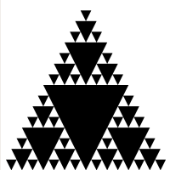 | 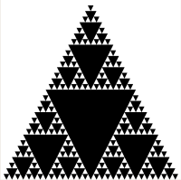 | 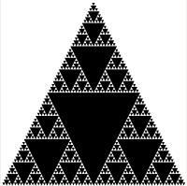
The recursive structure of the Sierpinski Triangle can be seen by looking at the order 3 triangle. In the order 3 triangle there are 3 smaller order 2 Sierpinski Triangles arranged around an order 1 Sierpinski Triangle. Similarly, if we look at the order 4 Sierpinski Triangle, it has 3 smaller order 3 Sierpinski Triangles arranged around an order 1 Sierpinski Triangle. Also note that the triangles added for order 2 are half the size of the triangle of order 1. Similarly, the triangles added for order 3 are half the size of the triangles added for order 2, and so on.
Implement the drawSierpinski() method in the SierpinskiPanel class. To see your triangle, run the main() method SierpinskiGUI class, which will display a JFrame containing a SierpinskiPanel that draws an order 6 Sierpinski Triangle. You do not need to create a JUnit test for the SierpinskiPanel class.
NOTE: This problem is based on one developed by Prof. Tim Wahls.

Submitting your solution
As usual, push your code to GitHub regularly for backup purposes and push your final version to submit the assignment. In addition, as usual, submit your lab report via Moodle. The lab report for this lab will consist only of the self-assessment report.

